1. Title
Automatic Night Light Using ATmega32 Microcontroller

2. Objective
The objective of this project is to design and simulate an automatic night light system using the ATmega32 microcontroller, LDR sensor, ADC, and LED.
The system automatically turns ON the LED in darkness and turns it OFF in light.

3. Components Required
Component | Quantity
ATmega32 Microcontroller | 1
LDR (Light Dependent Resistor) | 1
10kΩ Resistor | 1
LED | 1
220Ω Resistor | 1
5V Power Supply | 1
SimulIDE Software | 1
Microchip Studio | 1

4. Theory
An LDR (Light Dependent Resistor) changes its resistance according to light intensity.
- In bright light, LDR resistance decreases.
- In darkness, LDR resistance increases.
The LDR and 10kΩ resistor form a voltage divider circuit.
The output voltage of the divider is connected to the ADC input pin (PA0/ADC0) of the ATmega32 microcontroller.
The ADC converts the analog voltage into a digital value.
The microcontroller compares this value with a predefined threshold.
- If the environment is dark, the LED turns ON.
- If the environment is bright, the LED turns OFF.

5. Circuit Diagram
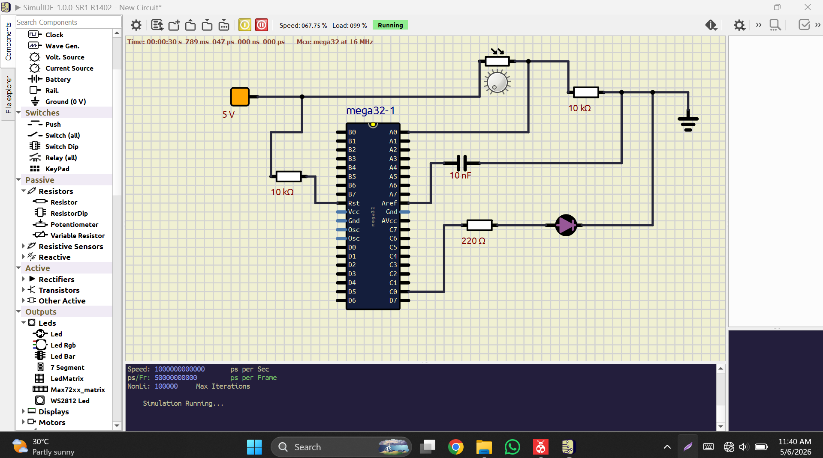

6. Pin Connections
ATmega32 Pin | Connection
VCC | +5V
GND | Ground
AVCC | +5V
PA0 (ADC0) | Voltage divider output
PC0 | LED
AREF | 10nF capacitor to GND

7. Voltage Divider Connection
5V → LDR → NODE → 10kΩ → GND
│
└──→ PA0 (ADC0)

8. Working Principle
- The LDR senses the surrounding light intensity.
- The voltage divider produces analog voltage based on light intensity.
- The ADC of ATmega32 reads the analog voltage.
- The microcontroller compares the ADC value with a threshold value.
- In darkness, the LED turns ON.
- In bright light, the LED turns OFF.

9. Assembly Language Program :
.org 0

ldi r16, (1<<REFS0) ; AVCC reference

out ADMUX, r16
ldi r16, (1<<ADEN)|(1<<ADPS2)|(1<<ADPS1) ; ADC enable + prescaler 64
out ADCSRA, r16
ldi r16, 0xFF
out DDRC, r16 ; PORTC output (LED)
; MAIN LOOP
MAIN:
sbi ADCSRA, ADSC ; start conversion
WAIT:
sbis ADCSRA, ADIF ; wait until done
rjmp WAIT
in r18, ADCL ; read low byte
in r19, ADCH ; read high byte
sbi ADCSRA, ADIF ; clear flag
; Compare threshold (example: 300)
ldi r20, low(300)
ldi r21, high(300)
cp r18, r20
cpc r19, r21
brlo DARK ; if less → dark
LIGHT:
cbi PORTC, 0 ; LED OFF
rjmp MAIN
DARK:
sbi PORTC, 0 ; LED ON
rjmp MAIN

10. Software Used
Software | Purpose
Microchip Studio | Writing and compiling assembly code
SimulIDE | Circuit simulation

11. Result
The automatic night light system was successfully simulated in SimulIDE.
- LED remained OFF in bright light.
- LED turned ON automatically in darkness.
The system successfully detected light intensity using the LDR sensor and controlled the LED automatically.

12. Advantages
- Low power consumption
- Automatic operation
- Simple and low-cost design
- Energy efficient

13. Applications
- Automatic street lights
- Smart home lighting systems
- Garden lighting
- Emergency lighting systems

14. Conclusion
The project successfully implemented an automatic night light system using the ATmega32 microcontroller and LDR sensor.
The ADC module effectively converted analog signals into digital values, enabling automatic control of the LED based on environmental light intensity.

